**CS4710/6710 Database Systems (Fall 2017)**

Instructor: Liyang Yu

**Assignment #6: Solutions**

**SANDHYA RAMADASAN:**

**002351924**

The following is a database design about students, who may major and minor in zero or more areas, where each area belongs to one school. The following ER diagram shows the idea:

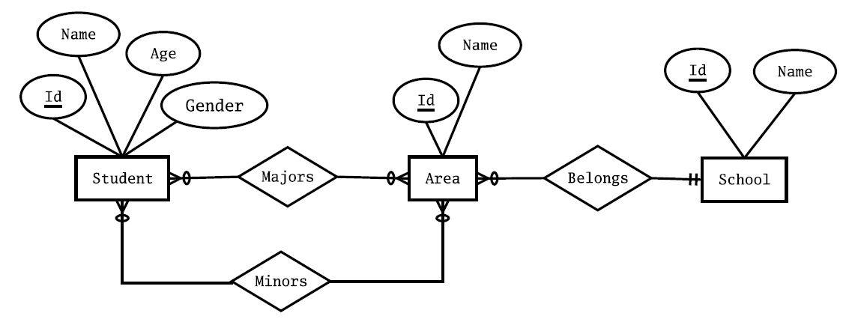

Clearly, all together 5 tables will be needed. The following are the SQL statements to create some of these 5 tables:

CREATE TABLE School (

Id INTEGER PRIMARY KEY,

Name VARCHAR(45) UNIQUE NOT NULL

);

CREATE TABLE Area (

Id INTEGER PRIMARY KEY,

Name VARCHAR(25) UNIQUE NOT NULL,

School INTEGER NOT NULL

REFERENCES School(id) ON DELETE CASCADE

);

CREATE TABLE Majors (

Student INTEGER

REFERENCES Student(Id) ON DELETE CASCADE,

Area INTEGER REFERENCES Area(Id),

PRIMARY KEY(Student,Area)

);

CREATE TABLE Student (

Id INTEGER PRIMARY KEY,

Name VARCHAR(30) NOT NULL,

Age INTEGER NOT NULL,

Gender CHAR(1) NOT NULL

CHECK(Gender IN ('M','F'))

);

CREATE TABLE Minors (

Student INTEGER

REFERENCES Student(Id) ON DELETE CASCADE,

Area INTEGER REFERENCES Area(Id),

PRIMARY KEY(Student,Area)

);

1. (4 pts, 2 pts each) write SQL statements to insert the following records into school table:

school id = 1, school name = “computing and software engineering”

school id = 2, school name = “tennis academy”

**INSERT INTO School(Id, Name) VALUES(1,'computing and software engineering');**

**INSERT INTO School(Id, Name) VALUES(2,'tennis academy');**

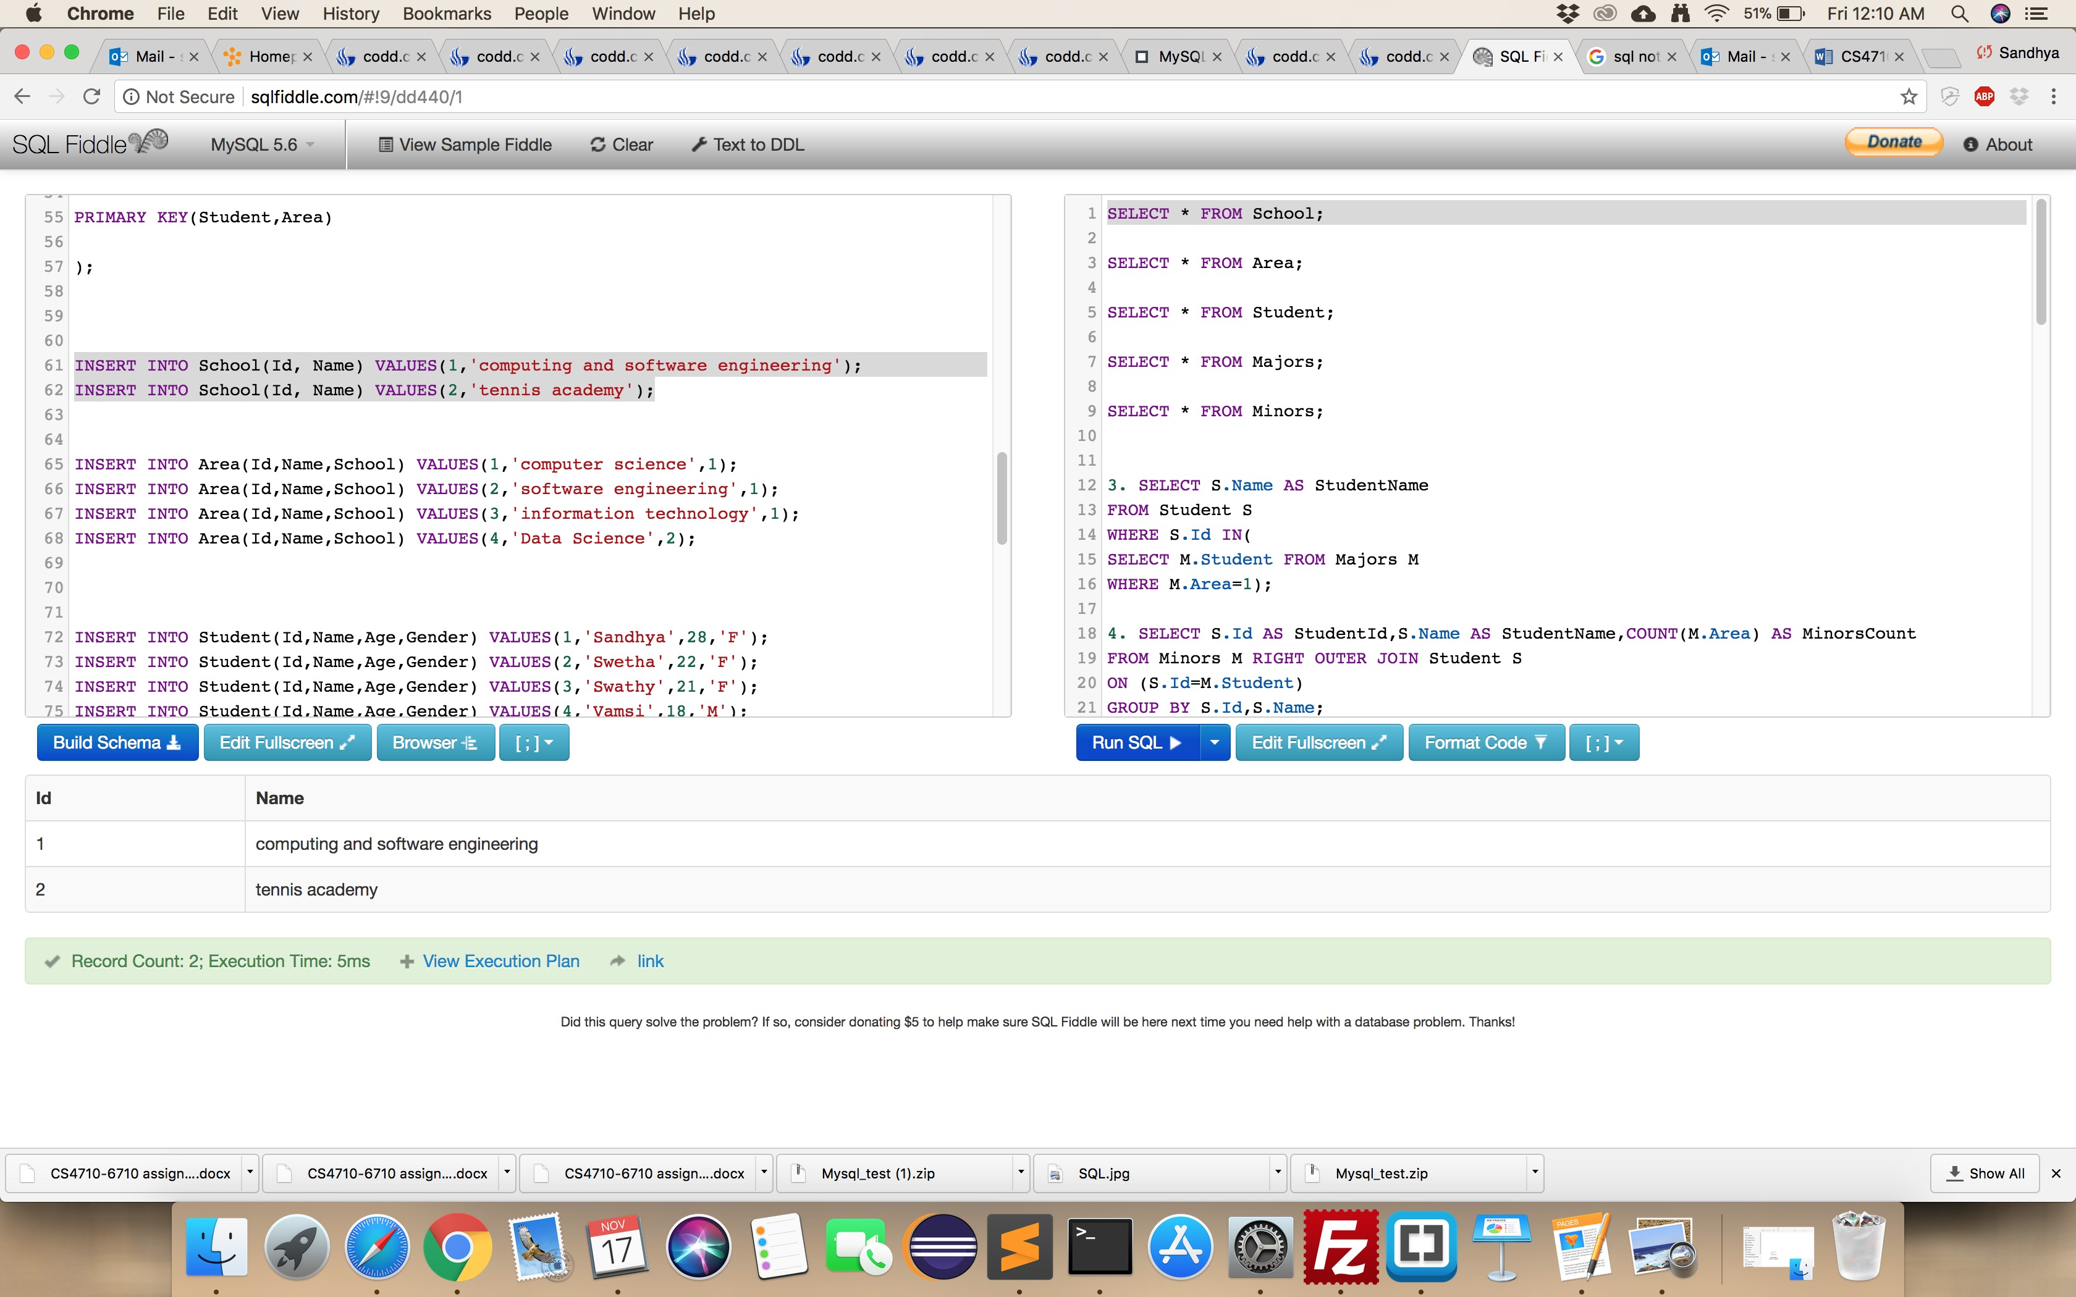

1. (6 pts, 2 pts each) write SQL statements to insert the following records into area table:

area id = 1, area name is “computer science”, which belongs to school id = 1

area id = 2, area name is “software engineering”, which belongs to school id = 1

area id = 3, area name is “information technology”, which belongs to school id = 1.

**INSERT INTO Area(Id,Name,School) VALUES(1,'computer science',1);**

**INSERT INTO Area(Id,Name,School) VALUES(2,'software engineering',1);**

**INSERT INTO Area(Id,Name,School) VALUES(3,'information technology',1);**

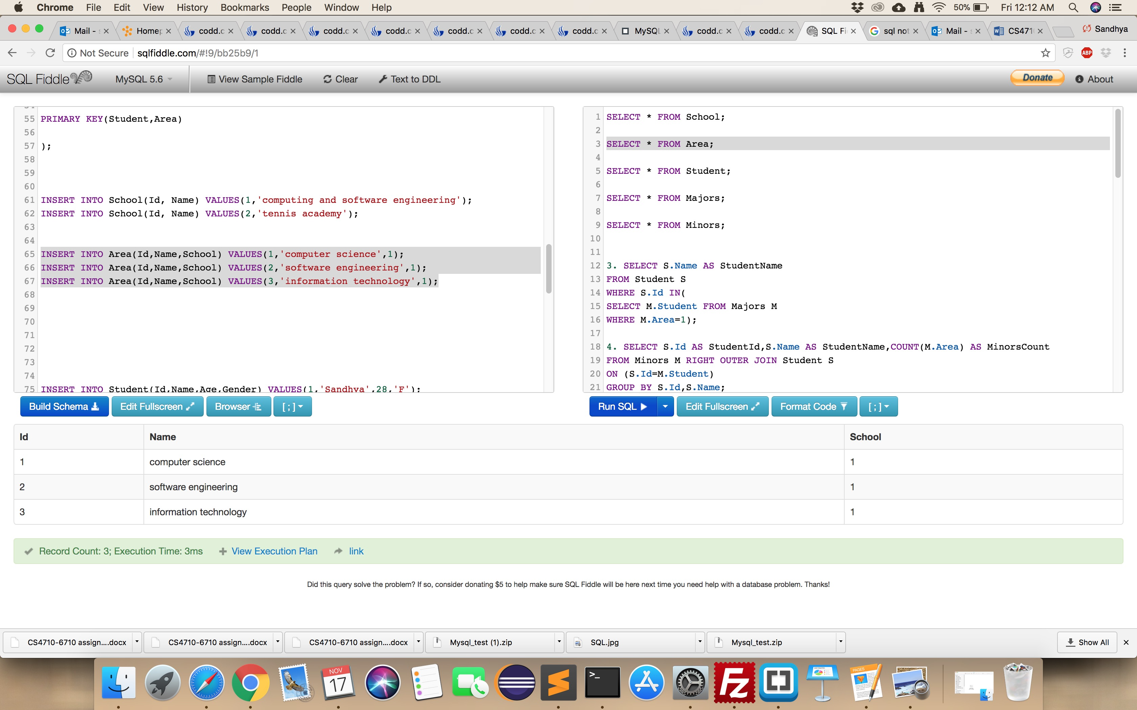

1. (8 pts) write SQL statements to show the name of the students who are majoring in the area with id 1.

**SELECT S.Name AS StudentName**

**FROM Student S**

**WHERE S.Id IN(**

**SELECT M.Student FROM Majors M**

**WHERE M.Area=1);**

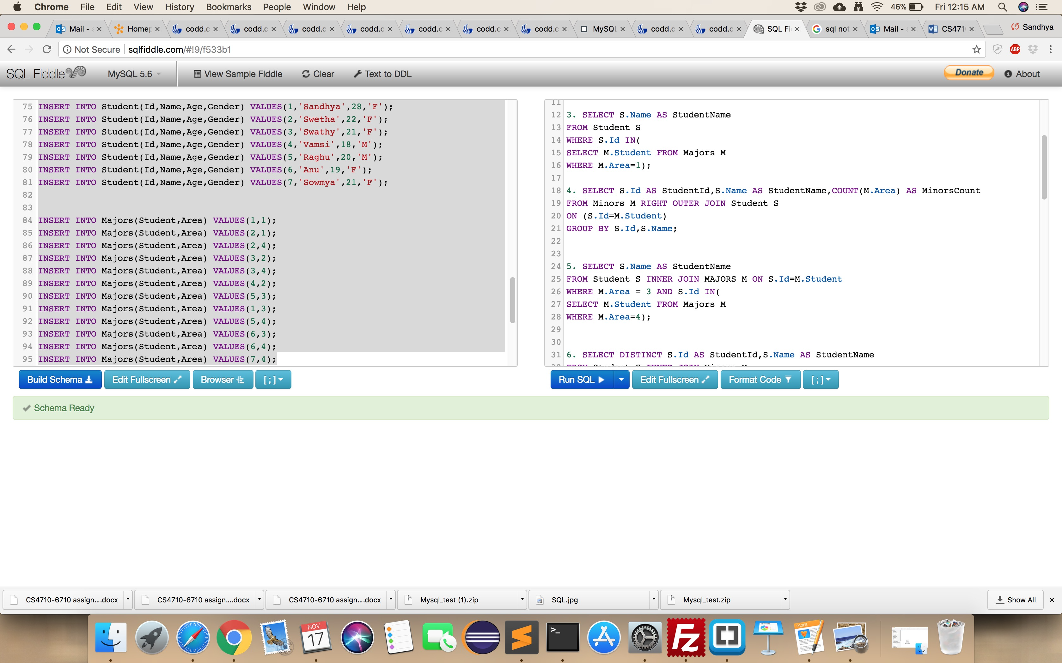

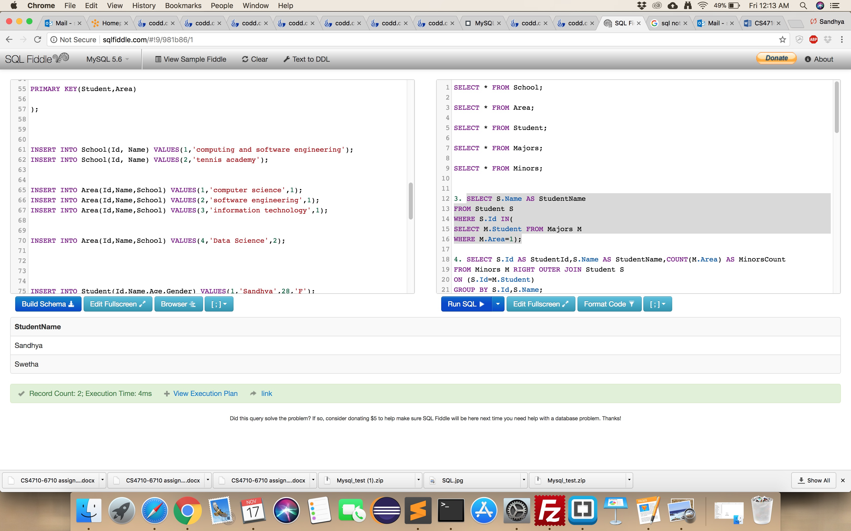

1. (12 pts) write SQL statements to show id and name of each student, with the number of areas they are minoring on.

**SELECT S.Id AS StudentId,S.Name AS StudentName,COUNT(M.Area) AS MinorsCount**

**FROM Minors M RIGHT OUTER JOIN Student S**

**ON (S.Id=M.Student)**

**GROUP BY S.Id,S.Name;**

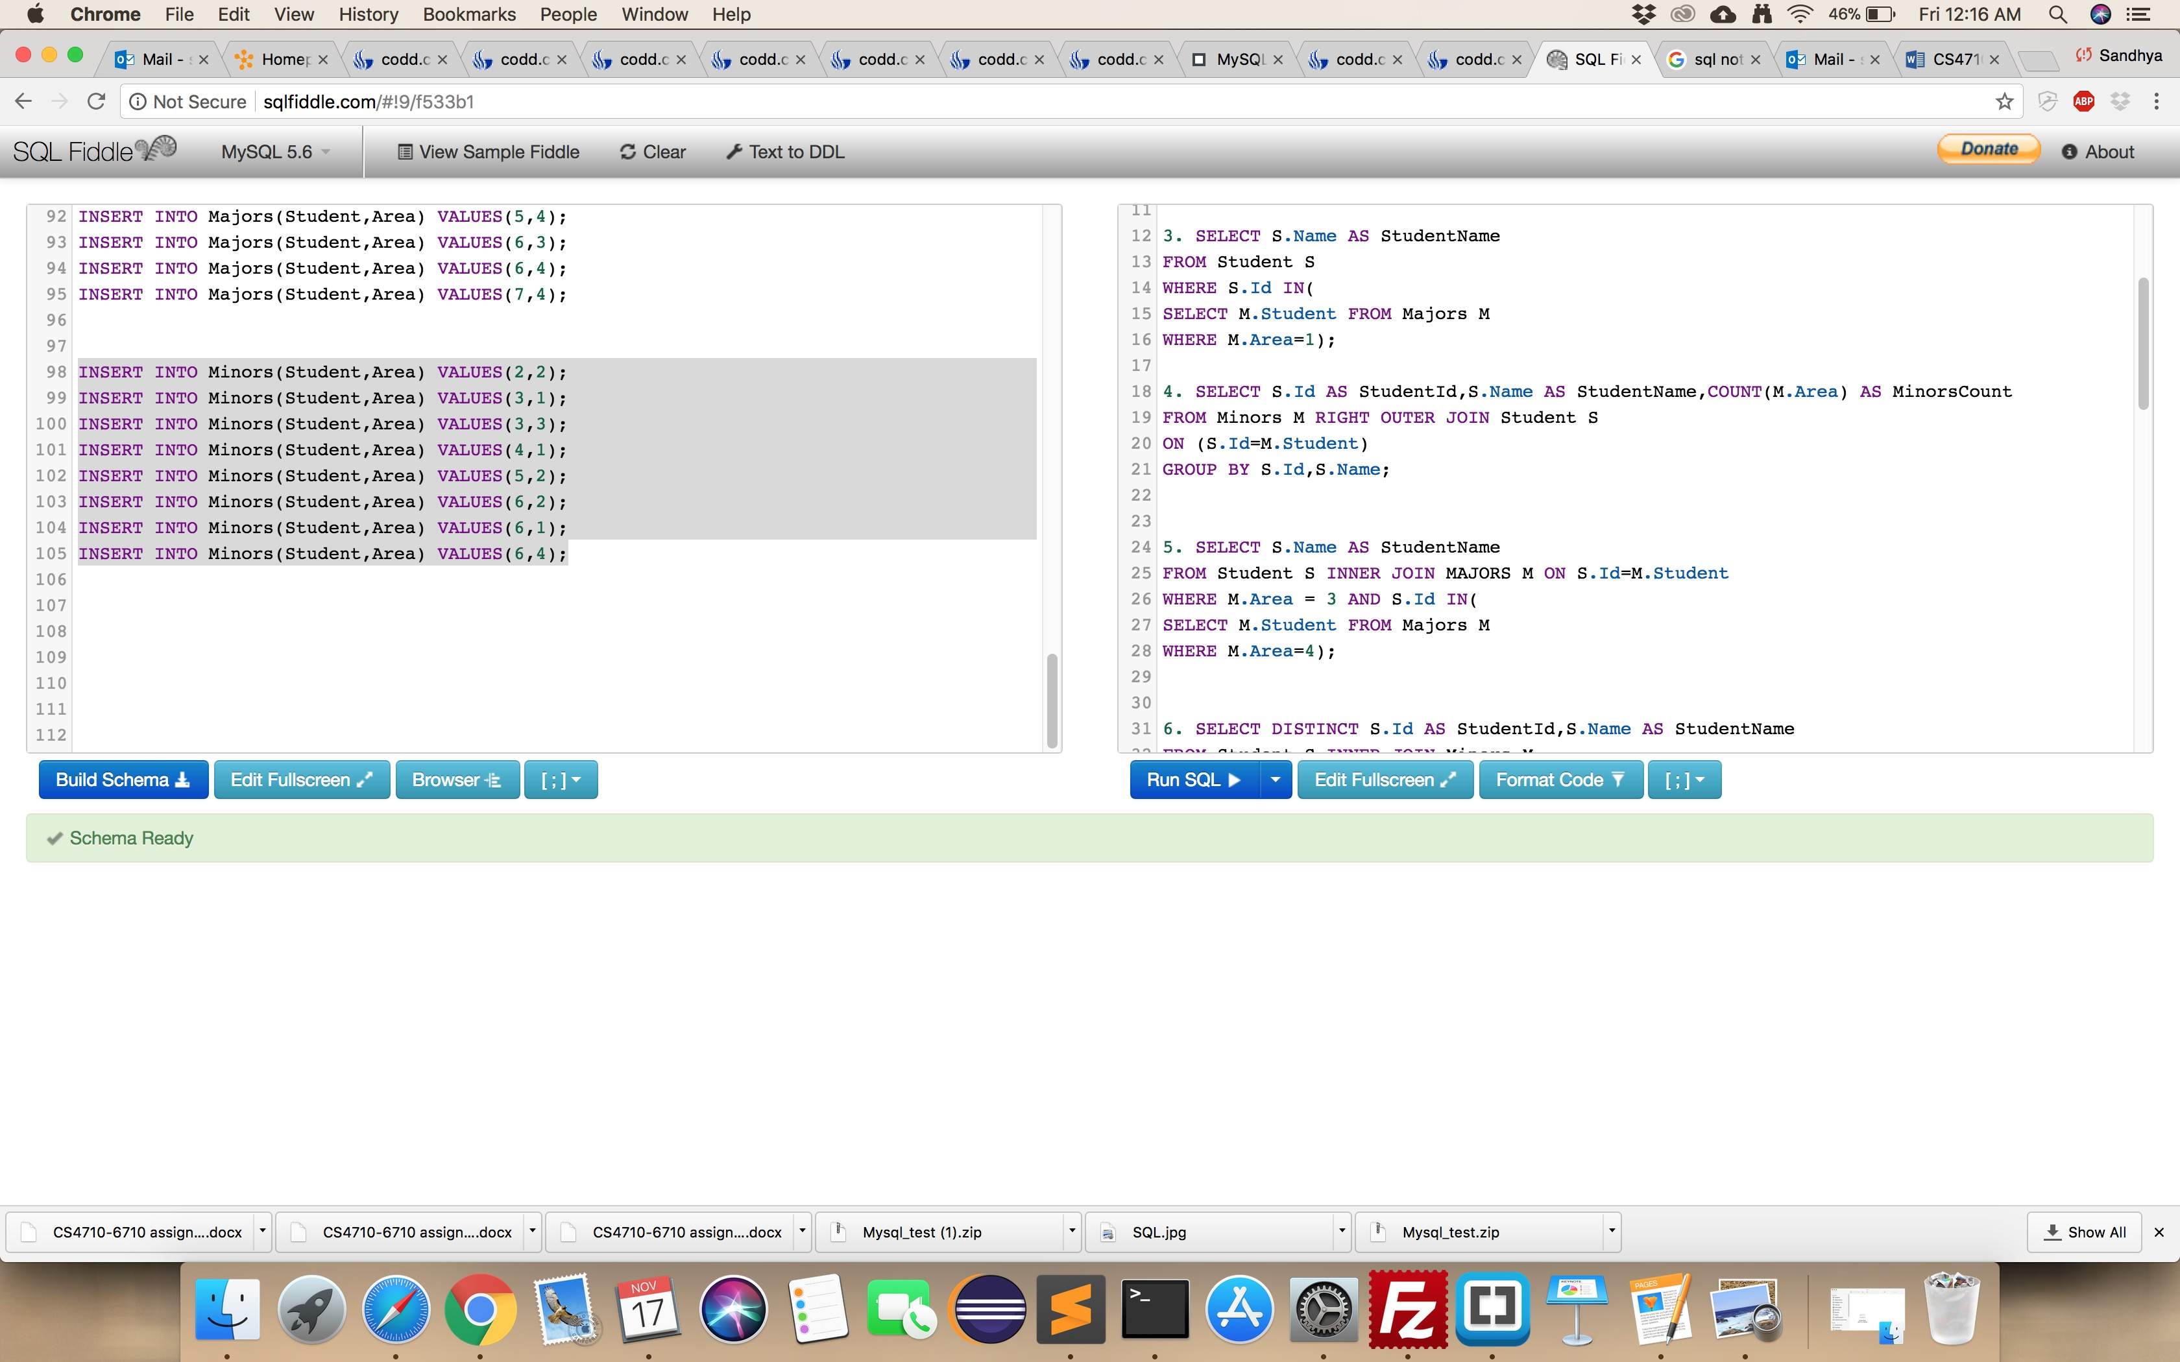

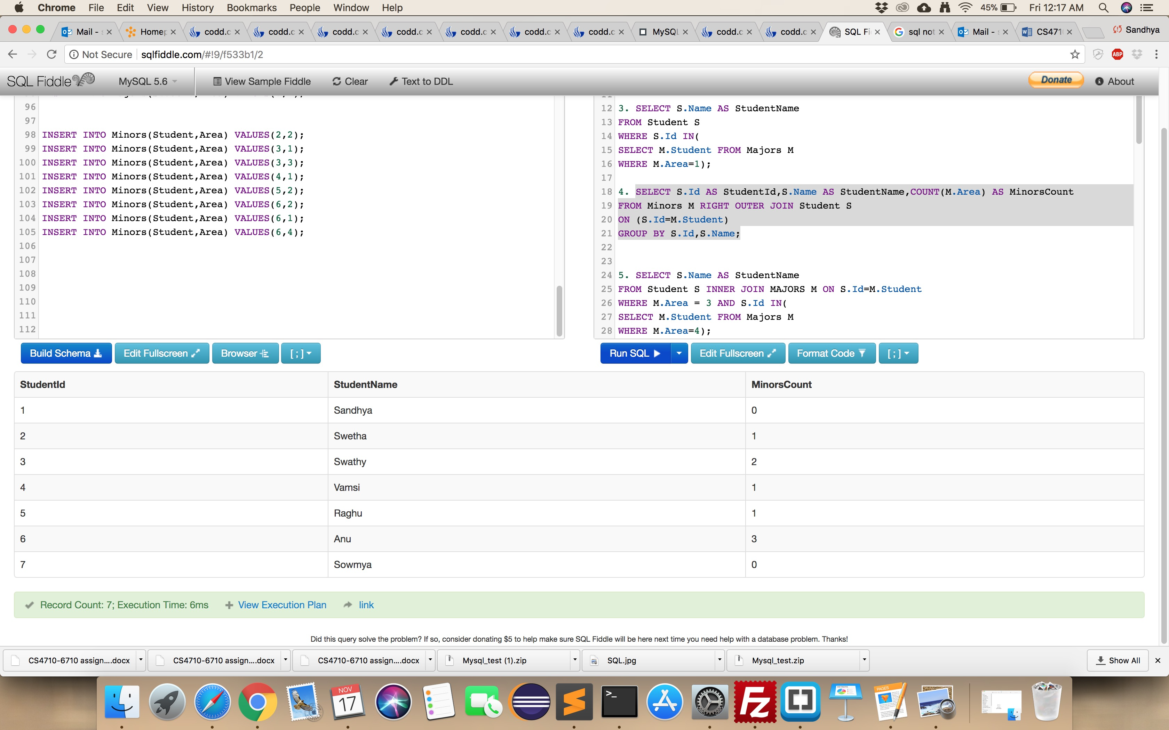

1. (20 pts) write a SQL query to display the names of all students who are majoring in BOTH area 3 and area 4

**SELECT S.Name AS StudentName**

**FROM Student S INNER JOIN MAJORS M ON S.Id=M.Student**

**WHERE M.Area = 3 AND S.Id IN(**

**SELECT M.Student FROM Majors M**

**WHERE M.Area=4);**

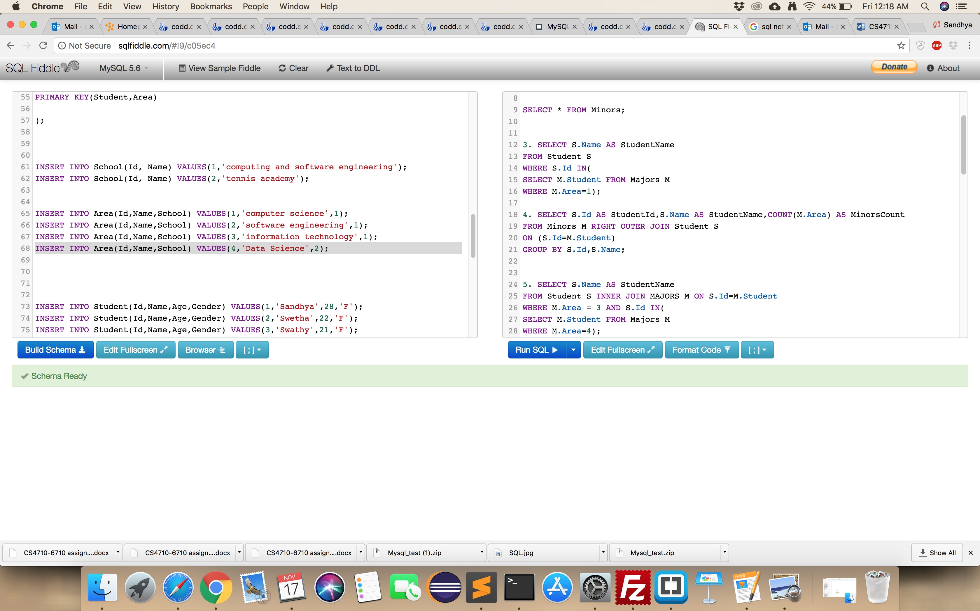

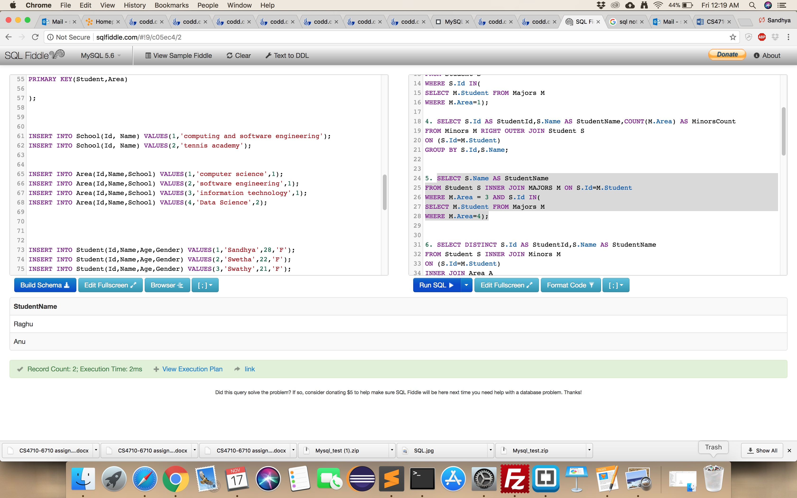

1. (20 pts) write a SQL query to show the id and name of all students who are minoring in any area belonging to the “tennis academy” school, make sure each student appears only once, even if minoring in more than one area within that school.

**SELECT DISTINCT S.Id AS StudentId,S.Name AS StudentName**

**FROM Student S INNER JOIN Minors M**

**ON (S.Id=M.Student)**

**INNER JOIN Area A**

**ON (M.Area=A.Id)**

**INNER JOIN School Sc**

**ON (A.School=Sc.Id)**

**WHERE Sc.Name='tennis academy';**

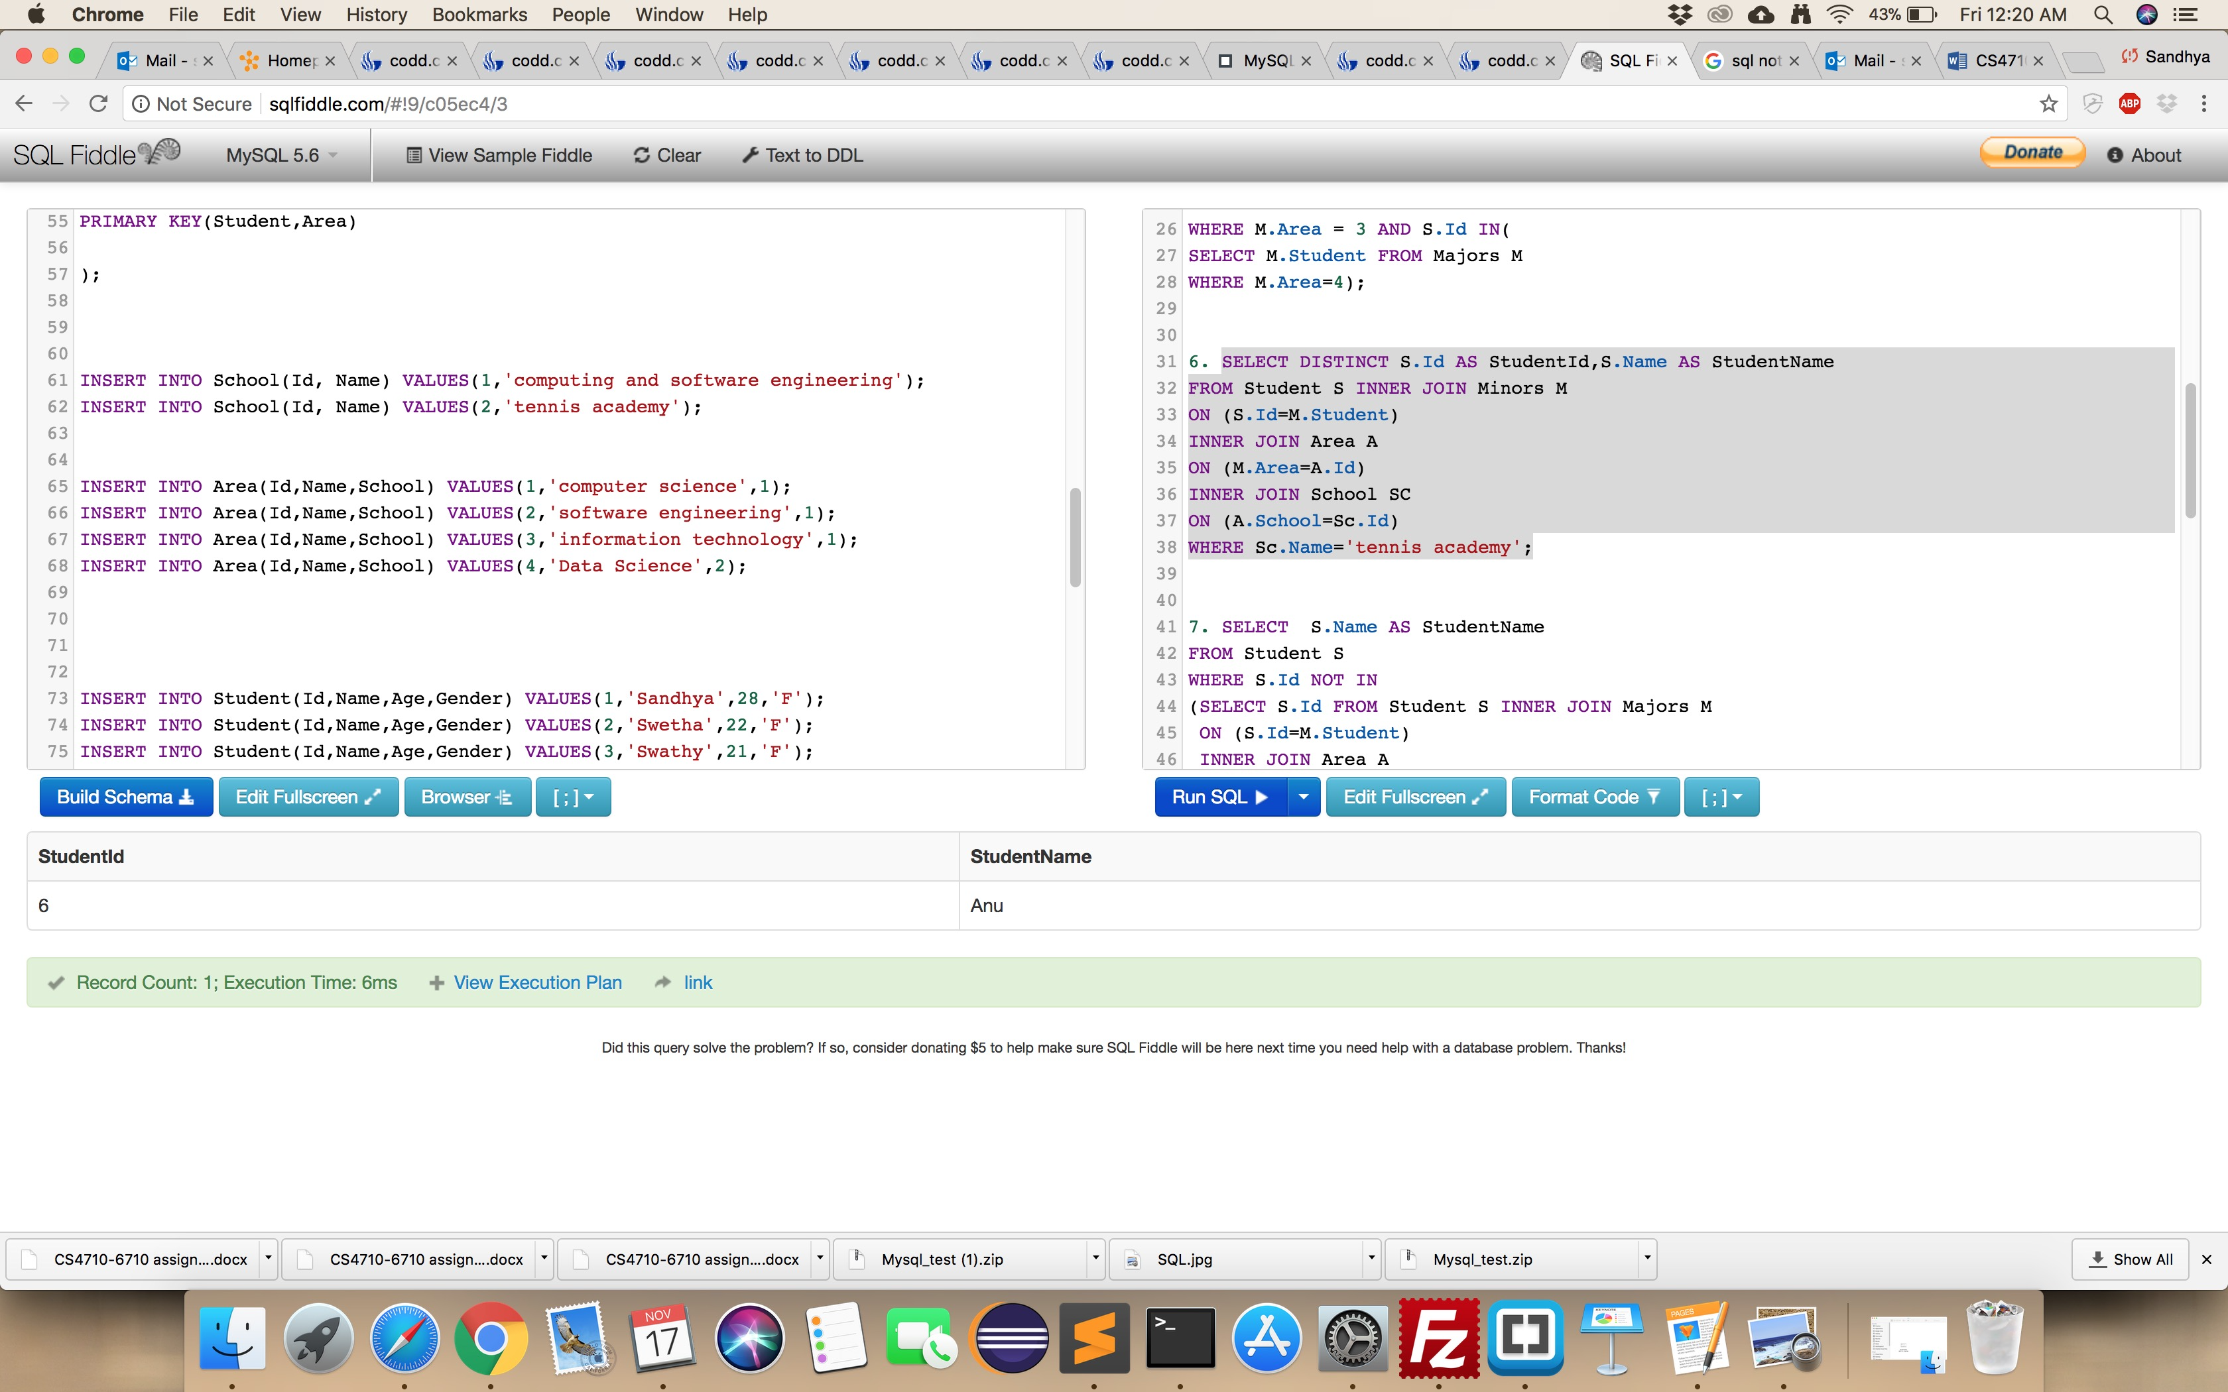

1. (20 pts) write a SQL query to show the names of any students who are NOT majoring in any area belonging to the 'Computing and Software Engineering' school.

**SELECT S.Name AS StudentName**

**FROM Student S**

**WHERE S.Id NOT IN**

**(SELECT S.Id FROM Student S INNER JOIN Majors M**

**ON (S.Id=M.Student)**

**INNER JOIN Area A**

**ON (M.Area=A.Id)**

**INNER JOIN School Sc**

**ON (A.School=Sc.Id)**

**WHERE Sc.Name='Computing and Software Engineering');**

